A quiet coast
  - FIELD NOTES / IMAGE & CAPTION EXAMPLE
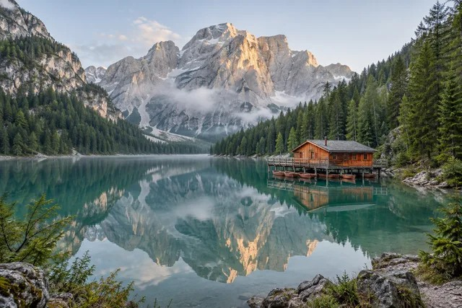
Figure 1. An illustrative landscape from the site’s example image collection.

Observations
A visual travel journal pairs one embedded image with a caption and ordinary body text. The picture lives inside the DOCX file; the preview does not need a remote image URL.
Use this sample to check image proportions, the caption and text spacing before printing.

